STUDENT NAME | R.ROJA
STUDENT REGISTRATION NUMBER | 251U1R2064 | CLASS: CSE AIML-C
PROGRAM | UG | YEAR and TERM:  1st year & 1st term
SUBJECT NAME | Fundamentals Of Web Development
NAME OF THE ASSESSMENT | Free Writing-I
DATE OF SUBMISSION | 19.10.2025

Video reflection:
1.what is HTML?
HTML (HyperText Markup Language) is the standard markup language used to create and structure the content of web pages. It is the most basic building block of any website and provides the framework that other technologies like CSS and JavaScript build upon. A web browser's purpose is to read an HTML document and display it as a web page.
2.Create a HTML file:
First we need to download vs code to create a file and to write program
<html>
<head>
<title>My First Web Page</title>
</head>
<body>

<h1>Hello, World!</h1>
<p>This is my first web page.</p>

</body>
</html>

This is how we write the program
Next, here we should save the file. First we need to go to file > save as.
Name it something like mypage1.html
Then top of the page click run then we need choose a browser open it with Chrome/Edge/Firefox.
We will see our output displayed in webpage.
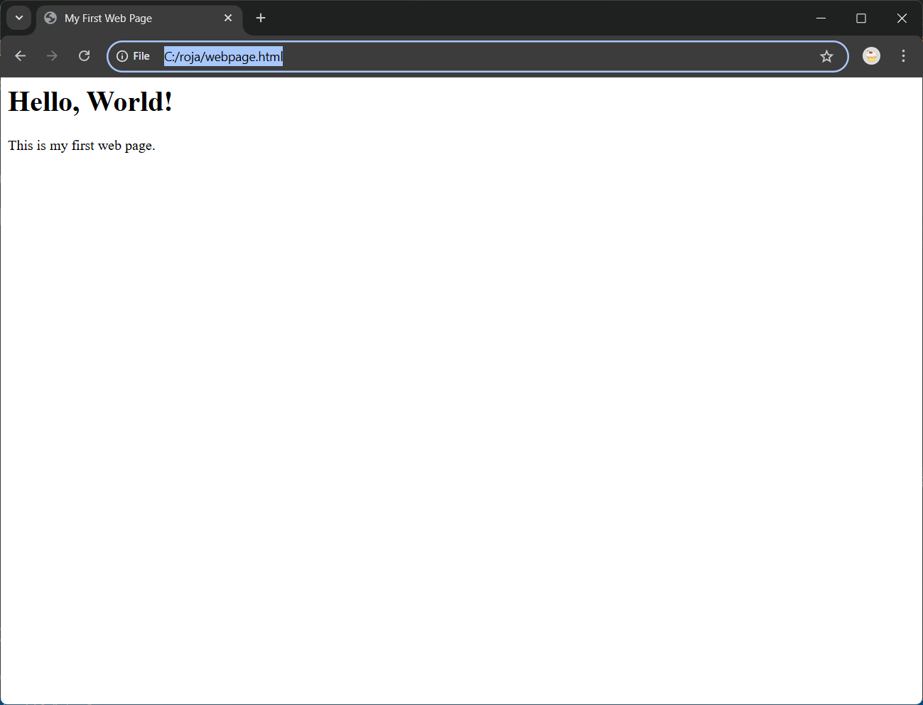
This is the output of the program
3.Edit Html file:
Find your .html file on your computer in VS code.
Right-click the file and choose open with VS code.
Now, make the changes inside the <body> tag.
Now save the file and view the output in your browser.
For Example:
This is the original
h1>Hello, World!</h1>

This is the edited page
<h1>This is my updated page!</h1>

4.Declarative language.
HTML, as a declarative language, is used to describe the structure and content of a web page rather than detailing the step-by-step instructions for how to display it. A web browser interprets these declarations to render the page, offering many practical applications in web development.
5.Header element.
The <header> element is a semantic HTML5 tag used to define introductory content or navigation links for a document or a specific section. Unlike the non-visible <head> element, the <header> is part of the visible content of a web page
6.Paragraph element:
The <p> element is a foundational HTML tag used to define paragraphs of text on a web page. Its primary purpose is to structure and organize text content into coherent, readable blocks. When you wrap text in <p> tags, browsers automatically add spacing before and after the paragraph, making the content more readable.
7.Inline elements:
Inline elements are HTML tags that do not start on a new line and only take up as much width as their content requires. They are primarily used to format and style text, create hyperlinks, and add other small, inline features within block-level elements like paragraphs or headings.
8.Nested elements:
Nested elements refer to the practice of placing one HTML element inside another. This is a fundamental concept for structuring and organizing content on a web page, creating a clear hierarchical or "parent-child" relationship between elements.
9.Markup language:
A markup language is a system for annotating a document to define its structure, format, and relationship between its parts. It uses a system of codes or "tags" that are inserted into text to provide instructions to a computer program, like a web browser. This is different from a programming language, which is used to execute logic and perform calculations.
10.Selection element:
The <select> element in HTML is used to create a dropdown list (or a selection list) in a web form. It allows users to choose one or more options from a predefined list. This element is a key component for collecting user input in a structured and space-efficient manner.
- Induction in HTML
Adding the spaces or tabs before lines of code is called induction in HTML.
Makes your HTML clean and easy to read.
Shows which elements are inside others(nested).
Helps you spot errors and understand structure.
- Unorderd List (<ul>)
Used to diplay a list of items.
Items are marked with bullets by default.
Each item is placed inside a <li> tag (list item).
The whole list is wrapped in a <ul> tag.
- Ordered List (<ol>)
Used to display a list of items in a specific order. These items are numbered (1, 2, 3…) by default.
Each item is placed inside a <li> tag and the whole list is inside in <ol> tag.
- Line Breaks (<br>)
Used to start a new line without starting a new paragraph.
The tag is <br> in short it is for “break”. Its an empty tag, meaning it doesn’t need a closing tag.
- Comments
It is used to add notes or explanations in your code. Its helps us or others to understand what the code does.
Useful for remainders, debugging, or hiding code temporarily. Comments do not affect how the page looks.
- Links and Anchor (<a>)
Used to connect one webpage to another.
The anchor tag is <a>, short for “anchor”.
We can add URL using the href attribute.
Can link to other websites, pages on the same site, email address, files or downloads.
- Images
Used to display pictures on a webpage.
The tag is <img> short for “image”.
Its an empty tag, meaning it doesn’t need a closing tag. We must include the src attribute to specify the image file.
- Audio element
Used to play sound on a webpage.
Needs the src attribute to link to an audio file.
Can include controls to show play/pause buttons. Common formats: .mp3, .wav, .ogg.
- Video Element
Used to play videos on a webpage. Needs the src attribute to link ta a video file.
Common formats: .mp4, .webm, .ogg.
- Table
Used to organize data in rows and columns. The main tag is <table>.
Rows are created with <tr> and the columns are created with <td> and the headers are created with <th> tag.
- Forms
Used to collect user input on a webpage. The main tag is <from>.
We can include fields like
Text boxes, radio buttons, checkboxes, drop down menus, submit buttons.
It uses the attributes like action and method.
- Structure Of HTML Page
The <html> tag is the main element to start the program and the <head> is used for headings which are under the <tittle> tag.
The <body> contains everything visible on the webpage, like headings ( <h1>, <h2>, <h3>), paragraphs(<p>), images(<img>), links(<a>), lists(<ul>, <ol>), tables, forms, sections etc.
At last </html> closes the HTML document.

